Exam 3:

Architecture of backend Golang and Frontend React Application:

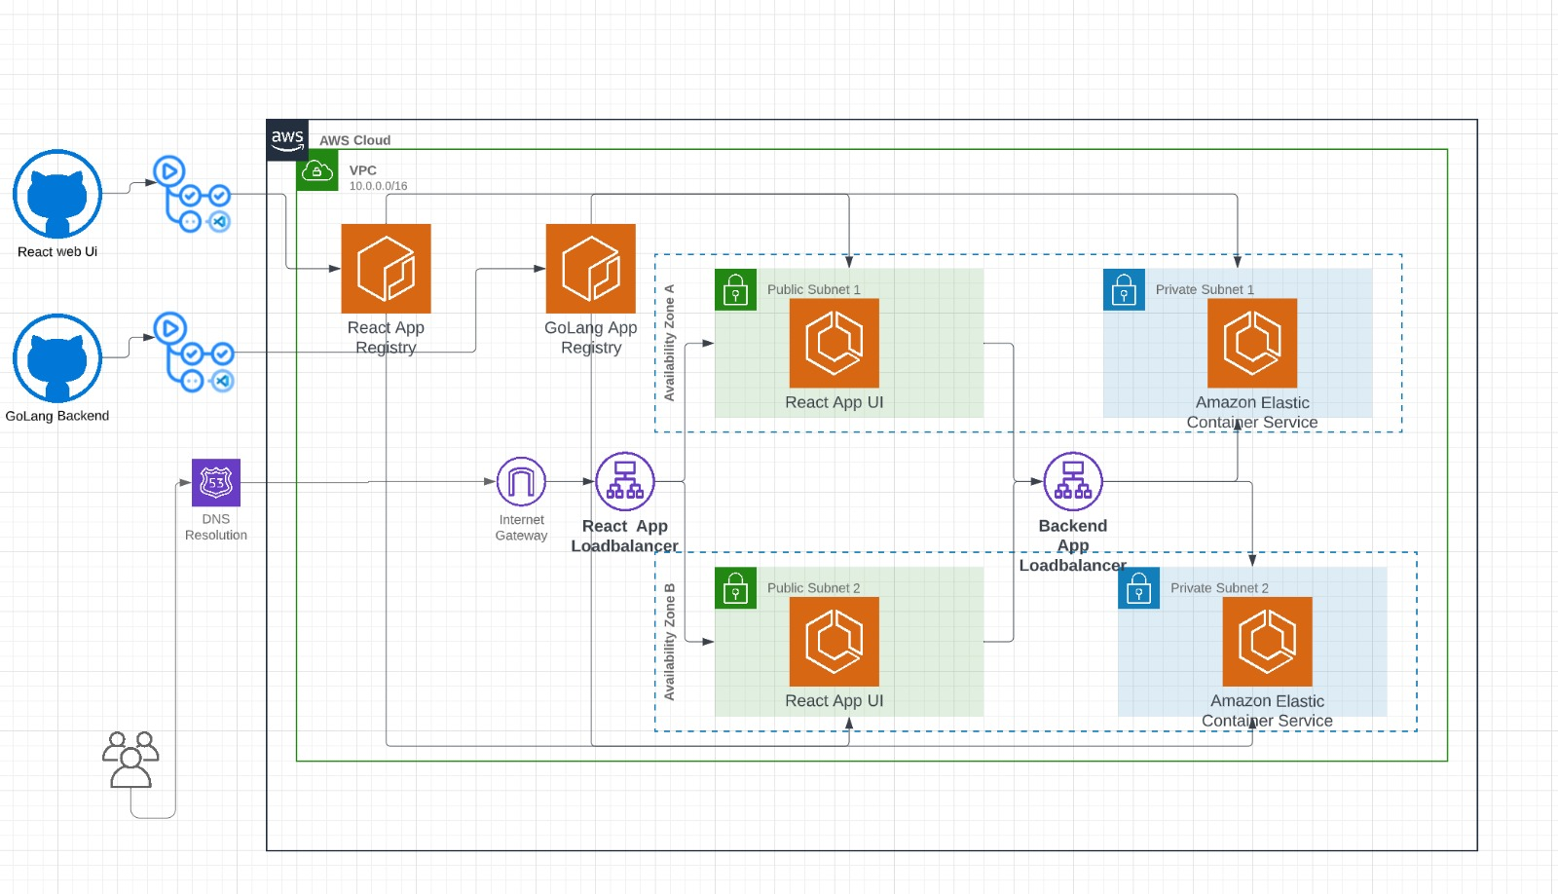

GitHub as source control for Golang backend, React App UI and Infrastructure Repository for AWS resources.

CICD Process React UI:

When a user commits on feature branch or a merge happens to main branch it will trigger GitHub actions and build the app inside docker image and publishes the image to ECR

Repository and deploy the container as a ECS service behind load balancer exposing 8080 for React Ui

CICD Process for Golang:

When a user commits on feature branch or a merge happens to main branch it will trigger GitHub actions and build the app inside docker image and copies artifact into docker image and publishes the image to ECR and runs the ECS service in Private VPC behind the load balancer exposing 9090 port for react app ui.

CICD Process for Infrastructure:

When a user commits on feature branch or a merge happens to main branch it will trigger GitHub actions and runs the terraform configuration to provision the infrastructure

In AWS account and stores the state file in s3 backend and when a new change detected in terraform GitHub actions will apply new terraform configuration updates to cloud environment.